**A2-2: Login User Control**

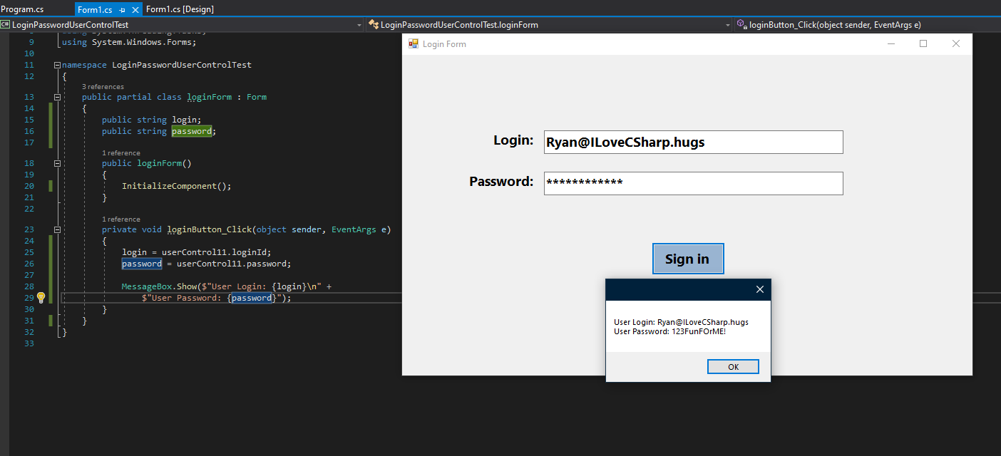

**GitHub link:** [**https://github.com/RyanLBuchanan/LoginPasswordUserControlTest**](https://github.com/RyanLBuchanan/LoginPasswordUserControlTest)